Title: Discourse around Sleep, Performance, and Work in the U.S. Print Media: 1983-2017.

Abstract
This computational social science study examines trends in sleep discourse in major U.S. newspapers from January 1, 1983 to December 31, 2017 (n = 25,766 newspaper articles) using Structural Topic Models supplemented by a close reading of selected articles. The data show tension between work and sleep, but also show attempts at ‘customization’ which emphasizes the importance of protecting sleep for performance and productivity. Further, the link between poor sleep and adverse health outcomes is increasingly emphasized. Naps emerged as a significant concept for discussion. Analyses suggest that Americans may view sleep’s relationship to work differently than in times past.

Introduction

If societies undergo change over time, so too might sleep norms and expectations. Drawing from historical books on manners, Elias in The Civilizing Process (1939) noted that as societies “civilized”, the practice of sleep began to shift from the social, communal sphere to a private one (1). Drawing from ethnographic research and historical archives, Wolf-Meyer (2012) investigated the Protestant origins of American sleep attitudes and the rise of sleep medicine and pharmaceutical interventions for sleep problems (2). Drawing from historical and literary texts, Reiss (2017) and Ekirch (2006) have observed that the norm of an uninterrupted 8-hour block of sleep a night (monophasic sleep) may be a historically recent ideal, prompted by the invention of electric lighting and a negotiation between factory workers and management in the wake of the Industrial Revolution and its punishing work schedules (3, 4). Thus arose the “Eight hours labour. Eight hours recreation. Eight hours rest.” formulation by the industrialist Robert Owen. To better understand the context of this formulation, let us briefly examine sleep in times past.

Pre-Industrial Revolution Sleep

A history of sleep in the Western world might usefully be divided into two time periods: pre- and post-Industrial Revolution. European pre-industrial societies tended to experience nightly sleep in two distinct segments. Sleep featured one major awakening as opposed to one segment with (ideally) no night-time awakenings. The first segment lasted approximately four hours and was called “first sleep” – in French, “premier sommeil or premier somme, in Italian, primo sonno or primo sono, and in Latin, primo somno or concubia nocte.” (4)

First sleep was followed by a brief awakening lasting an hour or more. Sometimes called “watch” or “watching,” this intermission allowed people to read, write, meditate, nurse infants, or make love. This night awakening was the norm: “So routine was this nightly interruption that it provoked little comment at the time… as a vital commonplace of an earlier age, country-folk yet knew about it in the early twentieth century.” (4) Following this brief intermission, “second sleep” would follow until morning awakening.

Pre-industrial sleep tended to follow nature’s rhythms in another sense: it changed in duration with the seasons. (5) One English physician observed that “In winter, longer sleepe is requisite than in Sommer.” (5) Cold winters with shorter days and often shorter food supply prompted rest instead of action. A British report of Russian peasants observed that in the lean winter months, “everyone would wake up once a day to drink some water and eat a piece of hard bread… Afterward, everyone went to sleep again.” (5) Similar circumstances prompted Canadian Inuits to lay mostly dormant through the frigid winter: “Changing sleep patterns were part of a cyclically occurring ebb and flow of supply and demand: sleep occurred in inverse proportion to supplies of food and heat.” (5)

A third feature of pre-industrial sleep is that it was primarily social. Even in the beginnings of the Industrial Revolution, the bedroom as it is commonly now viewed – a private sanctuary for sleep, relaxation, intimate conversations and/or sex – is a modern invention. (5) Bedrooms were for entertaining guests and for shared sleeping quarters. Elias’s The Civilizing Process devotes several pages to bed manners, for example, allowing the partner of higher social status to pick on which side he/she would prefer to sleep. Sleep was a social event, not a private one. In sum, pre-industrial sleep showed greater biphasic patterns, expansion during winter, contraction during summer, and was more social.

Post-Industrial Revolution

The Industrial Revolution marked a “taming” of sleep. (3) Sleep no longer followed nature – it followed work schedules. Work schedules were reorganized when work was reorganized – during the Industrial Revolution. Instead of naturalistic influences, it was the hands on a clock or the clang of a factory bell that prompted human action and repose (5). When work schedules became untenable, it was the workers who demanded standardization of work and sleep schedules: “What they pictured was a time that was reserved exclusively for sleep… The eight-hour ideal as we know it is largely a result of this push and pull between management and labor.” (5)

If pre-industrial sleep was social, post-industrial sleep marked a difference by privatizing sleep. Elias observed that “sleeping has been increasingly shifted behind the scenes of social life.” (6) In contrast to social Medieval sleepers, “for bourgeois European families, sleeping in private, out of view of others, became a hallmark of ‘civilization’ across the eighteenth and nineteenth centuries.” (5)

A further development of history with significant effects on the structure of sleep is the rise of technology. According to sleep physician Dr. Charles Czeisler, “Technology has effectively decoupled us from the natural 24-hour day to which our bodies evolved, driving us to go to bed later.” (7) Beginning with gaslight and later electric light, computers, and smartphones, sleep schedules were shaped by social technologic change; e.g. biphasic sleep merged to become consolidated monophasic sleep. (5)

Robert Owen’s classification of daily living suggests that expansion of one area – work, leisure, sleep – involves a reduction of another. Cultural sociologists in the U.K. have studied the relationship between sleep and work in the British print news media and found that the 1980’s saw an emphasis of work over sleep: “the power-elite such as Margaret Thatcher, Donald Trump and Bill Gates viewed sleep as sacrificial to their work and leisure time.” (8) This ethos was not restricted to the elite. According to Schor (1991) in The Overworked American, the Unexpected Decline of Leisure, “sleep has become another casualty of modern life often sacrificed in favor of long work hours, demanding work schedules and a twenty four-hour business culture.” (9)

Recent evidence, however, indicates that the trend of sacrificing sleep in favor of work may be undergoing re-examination, specifically that “sleep is now being more positively construed as the ultimate performance and productivity enhancer.” (8) In a qualitative study of 40 British men (2008), a primary purpose of sleep was to “[regain] the reserves and energy to do whatever you want to do the next day” because sleep is “critical for functioning in my job.” (10) U.K. researchers have suggested that sleep is being “customized,” (11) meaning that hard-nosed notions of over-work and under-sleep to avoid appearing lazy are reframed into a “recover better” ethic in which sleep is not a barrier for performance but rather an essential ingredient for it.

The Medicalization, Customization, and Healthicization of Sleep

The medicalization of sleep is not entirely a separate topic from sleep and work. The medicalization of sleep, according to Reiss (2017), was a direct consequence of new working conditions: “Sleep science emerged as a profound response to the industrial age, in which the rhythms of daily life came unstuck from the internal rhythms of workers, and experts were needed to understand what was happening in order to repair the damage.” (5)

Sleep has become medicalized in at least three senses: through the use of medical vocabulary to describe abnormal sleep, the use of medical institutions to address sleep problems, and in the interaction of patient and doctor in discussing sleep problems. (11) The media have been identified as playing a central role in the increasing awareness of people who have sleep troubles. (12)

Medicine, however, is only one avenue through which sleep is expressed as a health concern. In the U.K., researchers find evidence for “healthicization”. (13) Healthicization refers to the increasing understanding of proper and healthy sleep patterns as “an obligation of responsible citizenship.” (13) In a world increasingly out of sync with natural bodily rhythms, the responsibility on the individual to maintain healthy sleep for the sake of personal and public health has grown. (13) To be a responsible citizen, it is implied, one must sleep adequately to maximize performance at work, avoid work-place accidents, and maintain one’s health and the public health. In short, sleep and sleep problems have become medicalized, customized, and healthicized.

Modern research into the social construction of sleep in a Western context has primarily focused on media and newspapers in the U.K. According to DiMaggio et al. 2013, the news media are important because they can influence individual and collective views held by the reading public, partly because news articles may be built around quotes, ideas, or paraphrases from influential and credible individuals or institutions, and partly because (14), news articles can: 1) prime existing schematic representations (e.g. that sleep is important for health and performance), 2) development of new representations (e.g. “did you know that sleep is important for health and performance?”), 3) integration with broader schemata (e.g. good sleep associated with healthy lifestyles generally, and insufficient sleep is associated with work), 4) indirect influence through selective re-telling in social settings (e.g. “So, I read this article about sleep recently…”), 5) provide proxy value in illustrating the thoughts of opinion leaders or functions as a proxy for other exposures (e.g. someone who does not read the news about sleep may not be exposed to this information in the news but nevertheless could be exposed to this information via brochures or posts or billboards designed by individuals who read this news).

As has been suggested, sleep is being “redescribed” which is “sociologically interesting when it changes the way people routinely see, think, and behave towards themselves, others, and the world.” (12) To help fill this gap, 35 years of U.S. print media data were gathered. Leveraging the large-scale digital archiving of newspapers in aggregator archives which made automated search for textual data available for analysis from the 1980s (15), data were collected from January 1, 1983 to December 31, 2017, and modeled via a text mining algorithm, Structural Topic Models (16). The purpose of this report is to document and investigate the possible shifting significance of sleep over this time period, as prior reports in the U.K. suggest that sleep was viewed initially as a resource to be sacrificed in favor of work but potentially later viewed as a resource to be protected for the sake of productive work.

Results

Figure 1 shows the distribution of the corpus from 1983-2017. The number of news articles in which ‘sleep’ was in the title or abstract appears to have oscillated in the corpus with some years higher and others lower, with overall number of articles perhaps declining yet neither strictly increasing nor decreasing over time.

Figure 1. Count of articles in which “sleep” was in the title or abstract
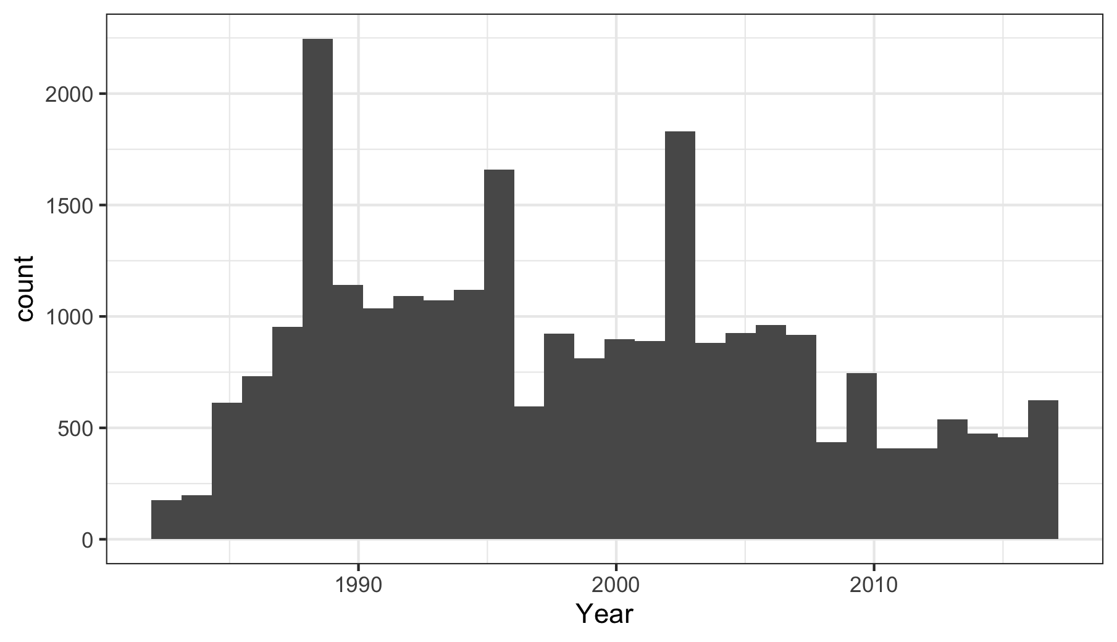

Table 1 shows the topics of interest with top terms by marginal probability (i.e. representative words) and marginal Score (words distinctive to the topic versus other topics). The 70-topic Structural Topic Model identified coherent topics (full list of top terms in Table S1). Topics include the relationship between sleep and technology, health risks of poor sleep, sudden infant death syndrome, the sports media, college students, and others. However, the focus in this report is on the topic of insufficient sleep and daily living including work (topic 33) and topics related to health (topic 32), cognitive performance (topic 47), and validation topics related to war (topic 50), and school start times (topic 7).

Table 1. Topics of interest and high marginal probability and Score words.
Topic 7:
Marginal Highest Prob: school, high, teacher, student, start
Marginal Score: elementari, school, student, teacher, teen
Topic 32:
Marginal Highest Prob: percent, studi, risk, health, report
Marginal Score: diabet, percent, studi, health, diseas
Topic 33:
Marginal Highest Prob: sleep, hour, get, day, time
Marginal Score: nap, hour, sleep, depriv, sleepi
Topic 47:
Marginal Highest Prob: research, studi, brain, univers, test
Marginal Score: hormon, research, brain, studi, scientist
Topic 50:
Marginal Highest Prob: war, bush, militari, armi, forc
Marginal Score: bush, war, militari, soldier, armi

The following sections begin with representative quotes of a topic, representative words (high marginal probability) of the topic and estimated trend in topic prevalence over time. Two validation topics are presented. Quotes are drawn from high probability articles (top 50 articles of highest topic proportion).

Topic 33: Sleep, work, functioning

Too little sleep means we're less alert, less productive and less efficient than we could be, and we're more prone to injuries and errors in judgment. We're also more likely to be forgetful, angry, cranky and irritable. This situation is likely to get worse as Americans trade sleep for work, television and other activities. USA TODAY 1998.

Figure 2. Work and sleep: top topic terms and expected topic proportions from 1983-2017
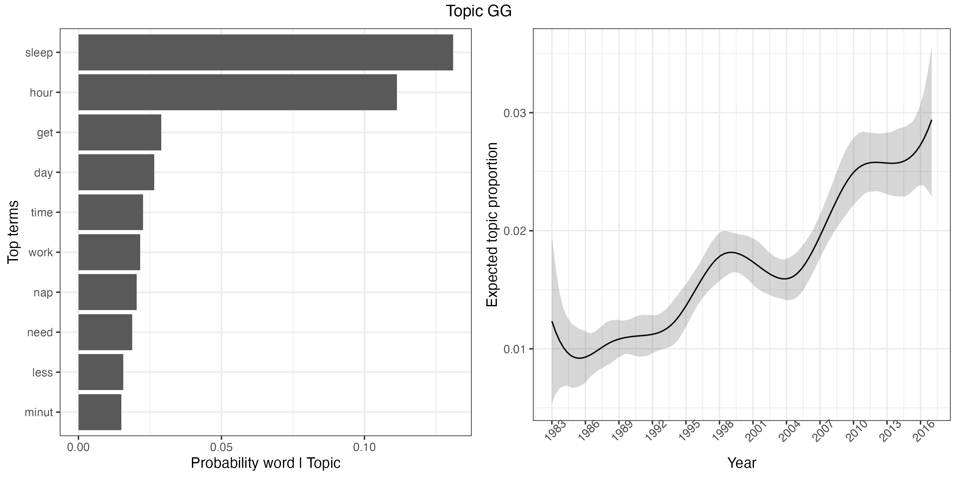
Figure 2 shows top probability terms (“hour”, “day”, “get”, “work”) which with a reading of the top 50 articles suggest that a common concern is when and how much to sleep, especially to be productive and alert for work. The top terms “nap” and “schedule” and a reading of the top 50 articles suggest that napping is an important subject in relation to work and night-time sleep. The data show an overall positive trend in prevalence of this topic, nearly a 2-3-fold increase in expected topic proportion from 1983 to 2017 (~0.01 to ~0.025).

Topic 32: Scientific research on poor health and sleep

People who slept, on average, six or fewer hours a night had a 48 percent greater chance of developing or dying from heart disease than did those who averaged seven to eight hours of sleep a night. – Washington Post (2011)

With less sleep, normal aging-related structural changes in the brain progress slightly faster in middle-aged and older people, according to a new brain imaging study. – Chicago Tribune (2014)

This topic relates to the recognition that poor sleep is an antecedent to other health outcomes. Figure 3 shows the growth in expected topic proportion and its top terms.

Figure 3. Health outcomes: top topic terms and expected topic proportions from 1983-2017
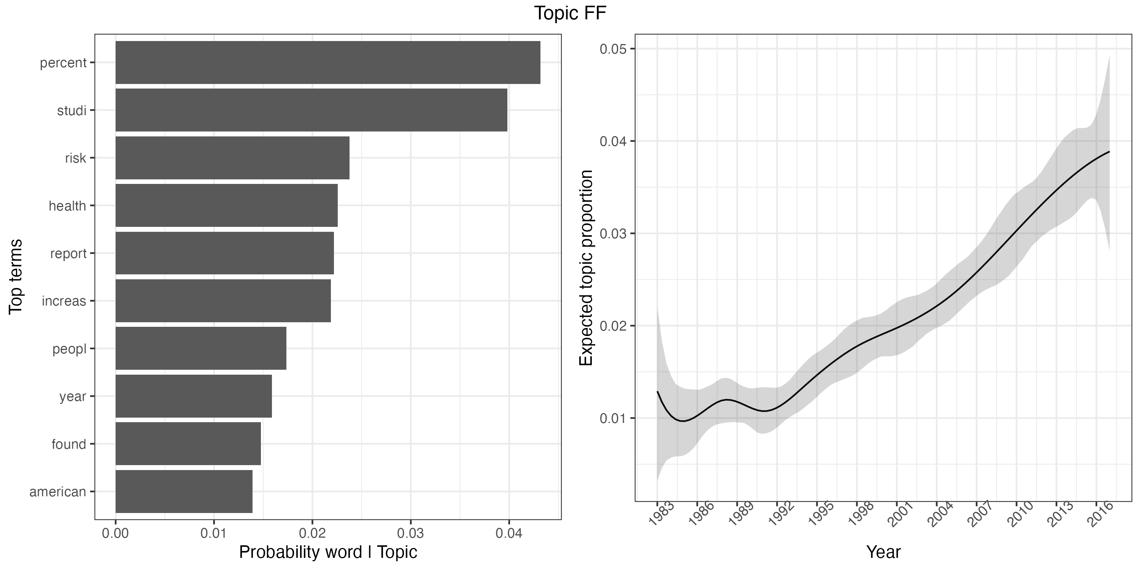
High probability terms in this topic (“studi”, “percent”, “research”, “report”, “health”) suggest that sleep research is a rich source of knowledge for science and health journalism. Furthermore, the high probability term “risk” indicates a negative orientation. The data suggest a quadrupling in attention from 1983 to 2017, from ~0.010 to ~0.045, to the serious health consequences of inadequate and poor-quality sleep.

Topic 47: Performance effects of Poor Sleep

All-night cram sessions may not be such a good idea after all. Researchers report that deep slumber plays an important role in learning, and, without it, hard-earned knowledge can disappear. – LA Times (1994)

Figure 4. Sleep and performance: top topic terms and expected topic proportions from 1983-2017
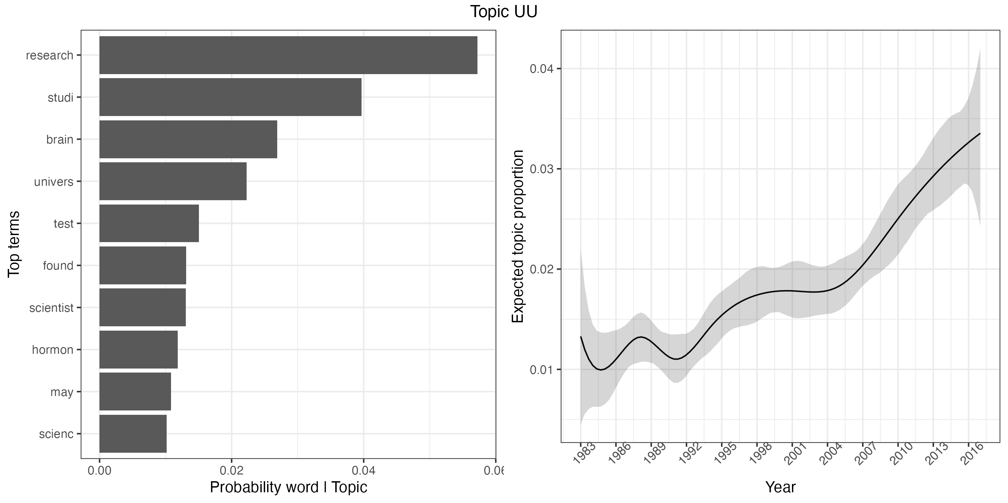

Figure 4 shows high probability terms (“research”, “studi”, “brain”, “test”), and a close reading indicate this topic is focused on scientifically supported research on sleep, including cognitive performance. The data indicate a 3-4 increase in expected topic proportion across time.

Validation topic: War (topic 50)

When in battle, the center's report said, ''commanders who fail to get enough sleep court disaster.'' It said that ''sleep deprivation causes leaders at all levels to make mistakes and decisions which directly or indirectly cause the 'death' of not only themselves but their units.'' New York Times (1998)

Figure 5. Sleep and war: top topic terms and expected topic proportions from 1983-2017
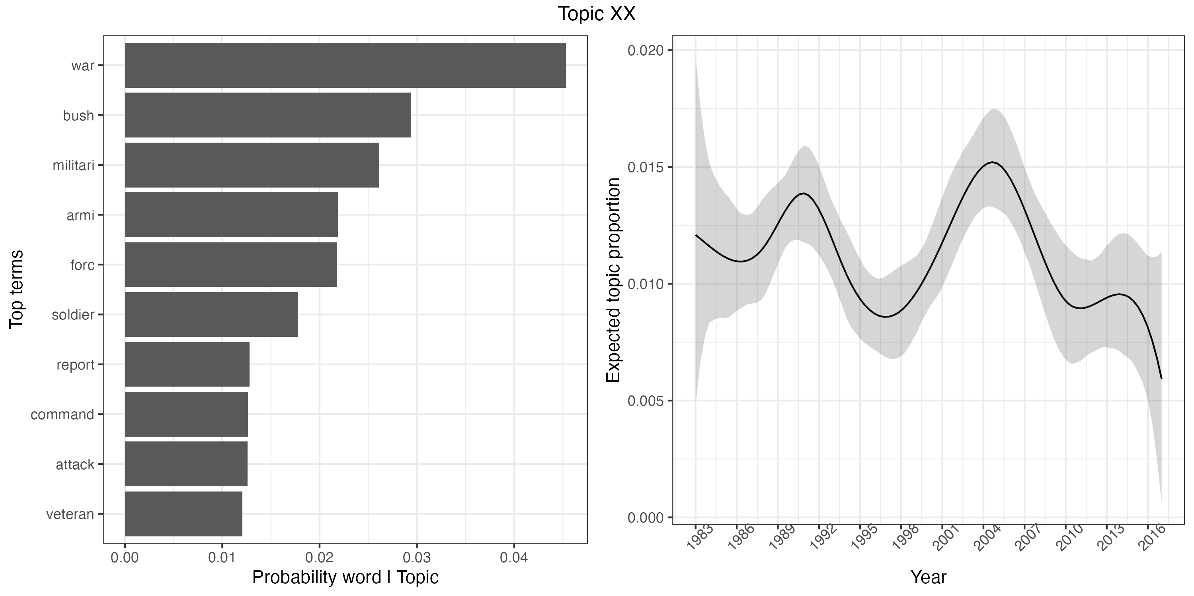
Figure 5 shows that that not all topics are increasing. During the time period of the 1st and 2nd Iraq wars there are peaks in topic proportion, with high probability terms: “Bush”, “war”, “militari”, and “soldier”. A reading of the top 50 articles showed focus on sleep in war settings, e.g., effect on decision making, where soldiers and journalists sleep, sleep deprivation as a human rights violation, and rest from battle.

Validation topic: School start times (topic 7)

Schools Superintendent Karen Garza plans to push for later start times at Fairfax County high schools next year [2015], aiming to begin their day no earlier than 8 a.m. in an effort to give teenagers more time to sleep. – The Washington Post (2014)

Figure 6. School start times: top topic terms and expected topic proportions from 1983-2017

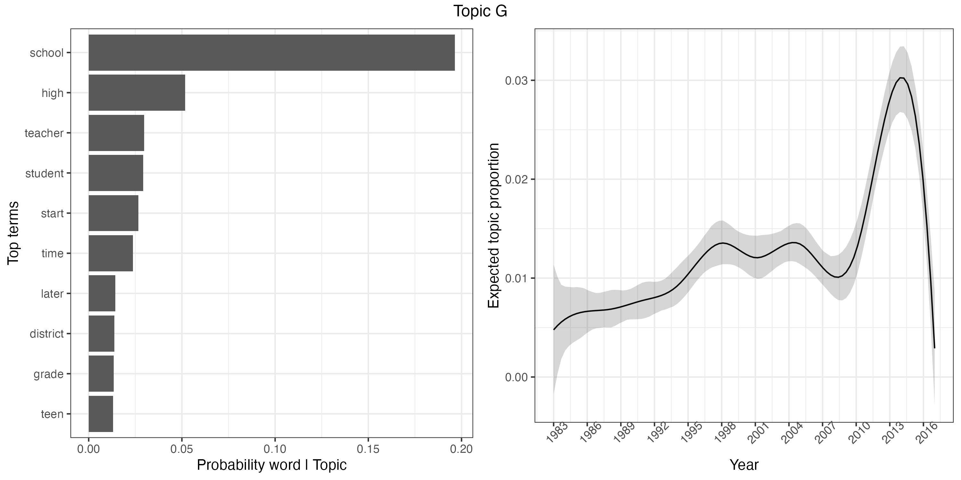

Figure 6 shows a peak in topic proportion as expected in 2014. As one article notes, the push for later school start times in Fairfax began in the early 1990s, but it appears that media coverage spiked in 2013-2014 when proposals were closer to becoming reality. Other topics and articles also show high face validity (see Table S1).

Discussion

U.S. print media data from 1983 to 2017 suggest that ‘sleep’ increasingly forms the basis for multiple discussions around well-being, productivity, health consequences of poor sleep, and tension with work. Why should we protect our sleep? According to corpus, the answer may lie in sleep’s status as a determinant of cognitive performance, cardiovascular health, well-being, and other health outcomes. The increasing prevalence of topic 32 focused on health outcomes suggests that this perspective occupies an increasing share of sleep focused news articles.

Yet sleep also forms the basis for important discussions around cultural values and work: are naps “un-American” as one article prompts? Another poses the conundrum that while a majority of polled readers said they don’t get enough sleep, nearly half also claimed that work-related matters keep them up at night. Some articles show attempts at ‘customization’, the reframing of sleep to work as less adversarial and more complementary. Similar to the UK print media, the US print media underscore the relationship between insufficient sleep and sub-optimal human performance. To contextualize this relationship, it may be helpful to consider a culture of sleep, attitudes toward sleep and its function in life.

A Protestant Ethic of Sleep

This story begins with the arrival of Protestantism. Sleep’s purpose, emphasized the devotional work The Whole Duty of Man (1691), is to restore “our frail bodies” to “make us more profitable, not more idle.” (17) Idleness was considered wasting time, which was “counted by God and paid for by men.” As Max Weber noted of Protestant beliefs in The Protestant Ethic and the Spirit of Capitalism, “Waste of time is thus the first and in principle the deadliest of sins... Loss of time through sociability, idle talk, luxury, even more sleep than is necessary for health, six to at most eight hours, is worthy of absolute moral condemnation.” (18)

Early, perhaps distinctively American attitudes towards sleep may be found in the writings of Benjamin Franklin (primary sources for Weber). Franklin felt motivated to comment on the British and French habit of socializing into the night, waking after dawn, and wasting candles and daylight in doing so: “the inhabitants of London chusing voluntarily to live much by candle-light, and sleep by sunshine, and yet often complain, a little absurdly, of the duty on candles and the high price of tallow.” ((19); see also (2)) Why not, he asks the French, rise when the sun rises? He writes to the Journal of Paris (19):

Your readers, who with me have never seen any signs of sunshine before noon… will be as much astonished as I was, when they hear of his [the sun] rising so early; and especially when I assure them, that he gives light as soon as he rises. I am convinced of this. I am certain of my fact. One cannot be more certain of any fact. I saw it with my own eyes. And, having repeated this observation the three following mornings, I found always precisely the same result… I say it is impossible that so sensible a people, under such circumstances [of heavy taxation], should have lived so long by the smoky, unwholesome, and enormously expensive light of candles, if they had really known, that they might have had as much pure light of the sun for nothing. (1784)

Surely, Franklin teasingly reasoned, if one values thrift and economy, one would take advantage of free light.

But for Franklin, it was more than just about candles. For Franklin, it was a spirit of industriousness and discipline that should motivate the early riser: “he that riseth late, must trot all day, and shall scarce overtake his business at night. While laziness travels so slowly, that poverty soon overtakes him.” (20) Franklin’s prescriptive writings such as his essay The Way to Wealth (1757) suggest his attitude towards early rising, idleness, and sleep:

How much more than is necessary do we spend in sleep! forgetting that the sleeping fox catches no poultry, and that there will be sleeping enough in the grave, as Poor Richard says. If time be of all things the most precious, wasting time must be, as Poor Richard says, the greatest prodigality… early to bed, and early to rise, makes a man healthy, wealthy and wise.

As Franklin in Poor Richard’s Almanack advises: “Plow deep, while sluggards sleep, and you shall have corn to sell and keep.” Although reports from contemporaries such as John Adams suggest that Franklin was not always consistent in his morning bird habits, particularly later in life in France, his writings serve as exemplars of certain cultural ideals around sleep and work.

U.S. Print News Media 1983-2017: sleep and work
It's a status symbol," he said. "If you are a good American, you work all hours. It's virtuous in American society to not get enough sleep. The Washington Post 2008.

Being able to say, 'I'm exhausted,' has become a badge of honor," Walsh says. "It's a macho thing. There's this idea that anybody who sleeps eight hours is lazy and can't possibly be productive. So people brag, 'I can get by on five hours of sleep or four hours of sleep.' Los Angeles Times 2007.

Historically, work and sleep have not always been conceived of as complementary. Some evidence in the U.S. suggests continued tension. As one article (an invited response commentary) says,

OK, what I see here are choices... No one is forcing someone to stay up and watch David Letterman… It all really boils down to priorities and time management. ... If you're not happy with how much sleep you get, make changes so you can get more. It really is that simple! – USA TODAY (2010)

This zero-sum relationship between sleep, work, and leisure is also noted in the Wall Street Journal (2017), which wrote that “Americans spent more time working and less time sleeping in 2016 than the year before, echoes of an improving labor market.” Less sleep, in this view, is expressive of work over sleep, a recurrent and prominent theme in the data. However, the data additionally note attempts to mold ‘sleep’ and ‘work’ into a less adversarial relationship, supporting the concept of ‘customization’ found in the U.K. news media (11).

U.S. Print News Media 1983-2017: effects of poor sleep on cognition and health and customization

Getting a good night's sleep after trying to master a tough new task might just reinforce what you have learned. – Chicago Tribune (2000)

Sleep deprivation does not just hurt workers-it hurts business, too, as 61% of workers say lack of sleep has had an impact on their work. USA TODAY 2016.

"Sleepiness is impairing their work, their relationships with their families and pretty much every aspect of their lives" The Washington Post 2008.

A recurrent theme across multiple topics was on the negative consequences of poor sleep (cognitive performance, physical health), which may help explain the motivation for protecting sleep and viewing it less as a resource to sacrifice but rather one which should be protected. Altogether, justifications for sleep are advanced as important for health and well-being, for work and cognitive performance, potentially motivating ‘customization’. As Williams et al. (2013) have defined it, customization functions to modify our sleep to accommodate demands of daily living “thereby helping remedy the increasing misalignment between biological and social time.” (11)

In many articles, sleep is framed as important for full engagement at work and for well-being. The consequences of poor sleep are directly linked to work. In Topic 33, top terms by probability (“hour”, “get”, “work”) and by Score (“nap”, “hour”, “depriv”) suggest a key concern is a lack of sleep and naps to catch up. The top article for Topic 33, for example, focused on sleep debt, “the chronic scrimping on sleep”, reporting survey results from 1994 that 53% of adults don’t believe they get enough sleep. The same 1994 article reports that 75% of respondents felt that sleep loss was bad for their health, whereas 48% nominated “Loss of energy” (48%) and “Crankiness” (20%) as the main consequences of insufficient sleep.

Often the articles included discussions that focus on problems that sleep deficiency creates such as poor performance and health (as one exemplar): “Studies have shown that sleepy workers make more mistakes and cause more accidents, and are more susceptible to heart attacks and gastrointestinal disorders.” (New York Times 2000). In response to the deficits that sleep deficiency creates for work performance and health, one article actually suggests an overhaul of the entire work week (later Monday start times, longer Wednesdays) for the sake of productivity. However, the more common customization suggestion was naps.

U.S. Print News Media 1983-2017: naps as customization

Emergency room doctors and nurses who worked overnight shifts and were allowed 40-minute naps showed a boost in alertness and performance over those who worked straight through. Chicago Tribune 2007.

Here is permission from a Mayo Clinic sleep specialist: it is okay to take a nap. USA TODAY 2009

According to the topic model, the term ‘nap’ was both common in topic 33 (marginal probability) and distinctive to this topic (marginal Score) (Figures 1, 2) as was the term ‘work’. Several themes were prominent: i) the American worker tends to be sleepy; ii) sleep is essential for performance; iii) a 10-20 minute nap may help; and iv) napping workers are judged negatively. Naps may be viewed more positively among sleep scientists than the general public. For example, a Letter to the Editor for the scientific journal SLEEP by Alger et al. (2019) called “Challenging the stigma of workplace napping” focuses on what sleep scientists as subject matter experts can add to the national discussion on napping (21). Noting the scientifically-supported benefits of napping to reasoning, problem solving, memory consolidation, alertness, productivity, emotion regulation, and stress and immune regulation, Alger et al. advance at least two perspective-shifting proposals on napping: estimating the costs of fatigue (costs of not napping), and countering a common perception that napping is equivalent to laziness. Authors note the rise in napping as fatigue countermeasures in large companies as well as segments of government agencies in which alertness and high cognitive performance are essential (e.g. NASA). On this view, stigma against napping is a barrier to greater performance.

Some news articles appealed instead to history and historical figures. One New York Times article (2000) cited Winston Churchill, Albert Einstein, Bill Clinton, and others as supporting examples for the author’s own napping preference, quoting Churchill’s recommendation: “Don't think you will be doing less work because you sleep during the day. That's a foolish notion held by people who have no imaginations. You will be able to accomplish more. You get two days in one, well, at least one and a half." In addition, there is a physiological explanation for this propensity for napping. A co-occurrence of a dip in natural biological rhythms with accumulating sleep pressure (increased time awake) with potential meal timing may, in fact, conspire to encourage an afternoon nap. Finally, there seem to be cultures that endorse napping or time allocated for rest near a mid-day meal. Although not universal within country, concepts such as the siesta (Spain), riposo (Italy), wu jiao (South China), inemuri (Japan), mesi meri (Greece), et al. suggest that the notion of ‘powering through’ the post-lunch dip is not a globally-shared idea. Nevertheless, despite some support by sleep experts and historical figures and some cultures in favor, American cultural sentiment appears to pose a barrier to full adoption of napping.

U.S. Print News Media 1983-2017: customization versus culture

“Slackers or an old person," said lifelong napper Karen Calhoun, 39, of Elk Grove, Calif., offering her take on America's opinion of nappers… Trouble is, there's plenty to get in the way of a good nap--guilt, jobs, commute time, appointments. "Our society has evolved to where napping is not part of our culture," Wytrzes said. – Chicago Tribune (2007)

Napping in the U.S. appears to retain association with laziness and unproductivity. There are implicit associations of napping with a lack of vigor (“an old person”). There are also moralistic valuations of sleep by reference to feelings of “guilt” and evaluations of nappers as “slackers”, echoes of the Protestant stance against the sin of wasting time.

Pronouncing nappers to be slackers may signal an outward conformity to cultural norms. In reality, it appears that unsanctioned workplace naps are/were common. One USA Today article (2016) cites a poll which claimed that “43% [of respondents] have caught someone sleeping at work.” These instances may be individuals succumbing to bodily needs or, perhaps, a sign of inexperience in disguising one’s workplace sleep:

Of those who take workplace naps, 70 percent say they do so secretly. "We've heard interesting stories on how people secretly nap," said William Anthony, 61, a Boston University psychologist. "A number of people--from 5 to 10 percent in our survey--do it in a bathroom stall. One lady told us she rests her head on the toilet paper roll." – Chicago Tribune (2003)

Thus, to nap at work is to invite social judgment, unless one has mastered the art of sleeping when no one is watching.

There seems to be a certain cultural ambivalence towards sleep: while acknowledged as important for health, performance, relationships, and other aspects of life, sleep continues to be a subject of debate. One 2000 article likened sleep to Rodney Dangerfield in that sleep gets ‘no respect’. Although one article in topic 7 about school start times noted that later start times is beneficial for school performance, sports, mental health, and driving accidents, other articles in this topic also noted push-back against modifying school start times (budgets, bus schedules, sports schedules, etc.). As one quoted parent said about school start times, "I feel if the issue was lead paint removal or asbestos, there would be no debate." (Topic 7; Washington Post, 2014) Certain discussions about sleep or naps are marked by debate and controversy rather than consensus.

In summary, there is evidence of what Williams et al. (2013) et al. have described as ‘customization’, an attempted molding of sleep and work into a less oppositional relationship. The impact of insufficient sleep and sleepiness on performance at work, relationships, and health is increasingly reported (11). Naps are sometimes endorsed but also treated skeptically and sometimes conducted in secret. One rationale for customization may be that since cultural attitudes towards work are unlikely change, and work is of prime importance, sleep must be framed as complementary to work. On the other hand, skepticism towards napping is perhaps a cultural counter force, and there is a consistent tension between time for sleep and time for work.

Study strengths include the focus on U.S. print media over a 35-year period (January 1, 1983 - December 31, 2017) to capture temporal trends. A strength of beginning the corpus in the 1980s is that data are reflective of the then contemporary drive to digitize archive news articles (15); few newspapers were consistently available for automated search before this decade. Future research may utilize historical newspaper media prior to the 1980s. A second strength is the use of Structural Topic Models, which are transparent, reproducible, and developed for computational social science research (16). STMs extend traditional topic models based on Latent Dirichlet Allocation by inclusion of meta-data, including year of publication for a longitudinal analysis, and allowance of inter-topic correlation. Further, topic models based on word co-occurrence illustrate a principle of cultural sociology that “meaning emerges from relations among terms rather than inhering within them.” (14) Alternative approaches may incorporate Large Language Models. Future research may evaluate other topics or time periods or additional sources of media such as social media; the Pew Research Center reports that 54% of adults ‘sometimes’ or ‘often’ get their news from social media (22). Finally, the COVID-19 pandemic altered sleep patterns on a global scale (23). The rise of work from home and hybrid arrangements have contributed to further population-level changes in sleep patterns (24). Future research may investigate the specific topics that became prevalent in public discourse during and after the pandemic and describe any perspective-shifts on the relationship between sleep and work.

Conclusion

An analysis of U.S. print media from 1983 to 2017 suggests attempts at ‘customization’, that is, towards the view of sleep as beneficial for performance and productivity. Nevertheless, work demands and cultural expectations also inform discourse around sleep, framed more ambivalently towards naps. America’s relationship with sleep and work could be viewed as an evolving discussion on how to square the necessity of sleep for optimal performance with the fact that an hour more for sleep is an hour less for work or leisure.

Materials and Methods

News articles from major U.S. newspapers written in 1983-2017 were acquired from ProQuest. The sampling time frame was not organized around a specific historical event but rather a hypothesized ‘vibe shift’ over time in the US print media that was evident in the UK print media. Publications were included if they were in the top 15 newspapers by circulation (Alliance for Audited Media) or digital traffic (Pew Research Center). (25, 26) Articles from the New York Times, Washington Post, Chicago Tribune, USA Today, the Wall Street Journal, the Orange County Register, and Los Angeles Times were collected. Articles were searched by the following criteria: 1) “sleep” appeared in the title or abstract; 2) were written between January 1st, 1983 to January 1st, 2018; and 3) were written and published in the U.S. For instance, Wall Street Journal articles written in Belgium on the European economy were excluded. The initial search returned 36,452 documents. Articles with full texts from 1983 to 2017 were retained for analysis (excluding January 1st, 2018). Duplicates were assessed and removed in two stages. First, a unique identifier was constructed from the date of publication, publisher, and number of characters in the title of the article, and one article was retained per unique identifier (resulting n=26,943). Second, cosine similarity of remaining articles was computed with a threshold of 0.7 (higher = more similar), and one duplicate was retained (final n=25,766)

The data were pre-processed in R. Each document was the unit of analysis. Stop words –such as “a”, “the”, and “and” – were removed. The text was lower-cased, and punctuation and URLs were removed. If a term did not occur in at least 500 out of the remaining documents, the term was dropped. Examples of dropped terms include names of books or people quoted in the media. The remaining terms were stemmed (e.g. when “sleep,” “sleeps,”, and “sleeping” are all equivalently treated as “sleep”).

Structural Topic Models (STMs) were used. (16) The number of topics (k), was set at 70 which is approximate to the 71-73 topic range suggested by running several open models with k=0, using spectral initialization. Thus, a 70-topic structural topic model was run on the corpus containing 25,766 documents. Data analysis was conducted using R 4.4.1 statistical software. Code development was assisted by Claude (Anthropic), an AI language model. All code was reviewed, validated, and customized by the author.

Analytic strategy

First, the trained Structural Topic Model was used to discover the highest probability words within each topic and to track a particular topic’s prevalence over time. A topic’s prevalence over time was measured by proportion: a Bayesian linear regression was run in which the outcome was the proportion of each document about a topic and the covariate was the year of publication for that document. Year of publication was b-spline transformed for smoothing and to capture non-linear trends. Second, STMs were further used to identify the highest Score terms that make the topic distinctive from other topics. Third, STMs were used to identify documents with high probability of containing a topic of interest so as to reserve them for closer reading. That is, the trained model can serve as a document search engine which uses “topics” instead of “key words” to identify documents to read. The in-built function findThoughts was used to return the top 50 documents considered to be most representative of each topic. Each article in the top 50 was read and analyzed.

Funding Declaration
I thank Dr. [redacted] who provided the departmental grant to attend an Inter-university Consortium for Political and Social Research (ICPSR) summer course “Machine Learning for the Analysis of Text as Data” (2017). This work was conducted primarily at [redacted] University and was supported by [redacted] University’s College of Arts and Sciences. The work was revised at the [redacted] and was partly supported by National Institutes of Health, [redacted].
Ethical Statement
Ethical approval was not required for this study as it involved analysis of publicly available news articles accessed through ProQuest and did not involve human participants or identifiable personal data.
Data Availability
The data that support the findings of this study are available from ProQuest. The raw news article texts are not publicly available due to copyright restrictions imposed by ProQuest and the original newspaper publishers (New York Times, Washington Post, Chicago Tribune, USA Today, Wall Street Journal, Orange County Register, and Los Angeles Times).
The code used for data processing, structural topic modeling analysis, and visualization is available from the corresponding author upon request. This includes R scripts for: (1) data preprocessing (stop word removal, stemming, deduplication); (2) structural topic model estimation using the stm package; (3) topic prevalence analysis with Bayesian linear regression and b-spline transformation; and (4) document retrieval and analysis.

Reference list
1. N. Elias, The civilizing process. (1939).
2. M. J. Wolf-Meyer, The slumbering masses: Sleep, medicine, and modern American life (U of Minnesota Press, 2012).
3. B. Reiss, Wild nights: How taming sleep created our restless world (Basic Books, 2017).
4. A. R. Ekirch, At day's close: night in times past (WW Norton & Company, 2006).
5. B. Reiss, Wild Nights: How Taming Sleep Created Our Restless World. (2017).
6. N. Elias (1939) 2000. The Civilizing Process: Sociogenetic and Psychogenetic Investigations (revised edition). (Cambridge, MA: Blackwell.[7]).
7. C. A. Czeisler, Perspective: casting light on sleep deficiency. Nature 497, S13-S13 (2013).
8. S. Boden, S. J. Williams, C. Seale, P. Lowe, D. L. Steinberg, The social construction of sleep and work in the British print news media. Sociology 42, 541-558 (2008).
9. J. Schor, The overworked American: The unexpected decline of leisure (Basic books, 2008).
10. R. Meadows, S. Arber, S. Venn, J. Hislop, Engaging with sleep: male definitions, understandings and attitudes. Sociology of health & illness 30, 696-710 (2008).
11. S. J. Williams, C. M. Coveney, J. Gabe, Medicalisation or customisation? Sleep, enterprise and enhancement in the 24/7 society. Social science & medicine 79, 40-47 (2013).
12. S. Kroll-Smith, Popular media and 'excessive daytime sleepiness': a study of rhetorical authority in medical sociology. Sociol Health Illn 25, 625-643 (2003).
13. C. Seale, S. Boden, S. Williams, P. Lowe, D. Steinberg, Media constructions of sleep and sleep disorders: A study of UK national newspapers. Social Science & Medicine 65, 418-430 (2007).
14. P. DiMaggio, M. Nag, D. Blei, Exploiting affinities between topic modeling and the sociological perspective on culture: Application to newspaper coverage of US government arts funding. Poetics 41, 570-606 (2013).
15. B. Garrison, Impact of computers on the total newspaper. Newspaper Research Journal 4, 41-64 (1983).
16. M. E. Roberts, B. M. Stewart, D. Tingley, E. M. Airoldi (2013) The structural topic model and applied social science. in Advances in neural information processing systems workshop on topic models: computation, application, and evaluation (Lake Tahoe, UT), pp 1-20.
17. R. Allestree, The Whole Duty of Man, Laid Down in a Plain and Familiar Way for the Use of All, But Especially the Meanest Reader (J. Baskett, 1724).
18. M. Weber, S. Kalberg, The Protestant ethic and the spirit of capitalism (Routledge, 2013).
19. B. Franklin, An economical project. Journal de Paris (1784).
20. B. Franklin, The Way to Wealth: Advice, Hints, and Tips on Business, Money, and Finance (Skyhorse Publishing Inc., 2011).
21. S. E. Alger, A. J. Brager, V. F. Capaldi, Challenging the stigma of workplace napping. Sleep 42, zsz097 (2019).
22. P. R. Center (2024) Social Media and News Fact Sheet, 2024. (Pew Research Center, Washington, DC).
23. N. Rezaei, M. A. Grandner, Changes in sleep duration, timing, and variability during the COVID-19 pandemic: large-scale Fitbit data from 6 major US cities. Sleep Health 7, 303-313 (2021).
24. S. A. Massar et al., Working-from-home persistently influences sleep and physical activity 2 years after the Covid-19 pandemic onset: a longitudinal sleep tracker and electronic diary-based study. Frontiers in Psychology 14, 1145893 (2023).
25. A. f. A. Media (2013) Top 25 U.S. Newspapers For March 2013.
26. P. R. Center (2015) Top-25-Newspapers-by-Digital-Traffic.

Extended data
Table S1. Highest probability and Score words per topic

Topic 1:
Marginal Highest Prob: sleep, disord, apnea, peopl, medic
Marginal Score: apnea, disord, insomnia, sleep, patient
Topic 2:
Marginal Highest Prob: game, hit, run, pitch, basebal
Marginal Score: inning, game, pitcher, basebal, pitch
Topic 3:
Marginal Highest Prob: will, saturday, friday, sunday, church
Marginal Score: funer, church, saturday, sunday, friday
Topic 4:
Marginal Highest Prob: homeless, shelter, peopl, servic, help
Marginal Score: homeless, shelter, volunt, church, servic
Topic 5:
Marginal Highest Prob: store, mattress, bed, shop, buy
Marginal Score: mattress, store, bed, retail, shop
Topic 6:
Marginal Highest Prob: anim, cat, human, adopt, bear
Marginal Score: cat, anim, adopt, fox, human
Topic 7:
Marginal Highest Prob: school, high, teacher, student, start
Marginal Score: elementari, school, student, teacher, teen
Topic 8:
Marginal Highest Prob: counti, jail, prison, sheriff, offici
Marginal Score: jail, counti, prison, sheriff, supervisor
Topic 9:
Marginal Highest Prob: babi, infant, parent, mother, birth
Marginal Score: infant, babi, parent, birth, pediatr
Topic 10:
Marginal Highest Prob: hotel, room, guest, inn, rate
Marginal Score: inn, hotel, guest, room, lodg
Topic 11:
Marginal Highest Prob: room, can, design, use, space
Marginal Score: pillow, room, space, design, bedroom
Topic 12:
Marginal Highest Prob: game, point, play, said, score
Marginal Score: rebound, game, playoff, victori, score
Topic 13:
Marginal Highest Prob: flight, travel, airport, plane, airlin
Marginal Score: airlin, flight, airport, plane, passeng
Topic 14:
Marginal Highest Prob: michael, brown, jackson, told, gari
Marginal Score: jackson, michael, brown, vega, las
Topic 15:
Marginal Highest Prob: dream, life, one, mind, peopl
Marginal Score: dream, nightmar, memori, emot, mind
Topic 16:
Marginal Highest Prob: music, song, band, perform, danc
Marginal Score: album, music, song, band, danc
Topic 17:
Marginal Highest Prob: park, camp, summer, tent, day
Marginal Score: camp, park, tent, summer, cabin
Topic 18:
Marginal Highest Prob: dog, pet, owner, home, put
Marginal Score: dog, pet, owner, rescu, anim
Topic 19:
Marginal Highest Prob: drink, alcohol, smoke, coffe, can
Marginal Score: caffein, drink, alcohol, smoke, coffe
Topic 20:
Marginal Highest Prob: presid, campaign, democrat, clinton, vote
Marginal Score: clinton, democrat, republican, senat, campaign
Topic 21:
Marginal Highest Prob: money, fund, stock, year, market
Marginal Score: stock, fund, invest, market, tax
Topic 22:
Marginal Highest Prob: king, goal, wilson, ice, brian
Marginal Score: duck, king, wilson, goal, ice
Topic 23:
Marginal Highest Prob: street, black, peopl, man, block
Marginal Score: gang, street, neighborhood, black, gun
Topic 24:
Marginal Highest Prob: show, news, call, will, phone
Marginal Score: chart, comput, internet, network, onlin
Topic 25:
Marginal Highest Prob: won, world, win, sport, olymp
Marginal Score: olymp, won, win, championship, athlet
Topic 26:
Marginal Highest Prob: love, will, friend, husband, dear
Marginal Score: dear, love, husband, marri, marriag
Topic 27:
Marginal Highest Prob: drug, use, medic, effect, treatment
Marginal Score: prescrib, drug, pill, patient, medic
Topic 28:
Marginal Highest Prob: photo, illustr, caption, chicago, color
Marginal Score: text, photo, caption, illustr, chicago
Topic 29:
Marginal Highest Prob: film, movi, play, star, show
Marginal Score: film, movi, actor, comedi, theater
Topic 30:
Marginal Highest Prob: hous, home, fire, live, apart
Marginal Score: fire, hous, apart, home, build
Topic 31:
Marginal Highest Prob: island, water, boat, river, fish
Marginal Score: boat, island, fish, sea, river
Topic 32:
Marginal Highest Prob: percent, studi, risk, health, report
Marginal Score: diabet, percent, studi, health, diseas
Topic 33:
Marginal Highest Prob: sleep, hour, get, day, time
Marginal Score: nap, hour, sleep, depriv, sleepi
Topic 34:
Marginal Highest Prob: case, death, charg, kill, investig
Marginal Score: juri, prosecutor, murder, testifi, attorney
Topic 35:
Marginal Highest Prob: race, run, ride, hors, mile
Marginal Score: hors, race, ride, bike, mile
Topic 36:
Marginal Highest Prob: govern, nation, will, polit, countri
Marginal Score: reagan, govern, polit, minist, nation
Topic 37:
Marginal Highest Prob: can, may, problem, pain, depress
Marginal Score: headach, symptom, depress, pain, stress
Topic 38:
Marginal Highest Prob: travel, trip, tour, includ, cruis
Marginal Score: cruis, tour, travel, trip, tourist
Topic 39:
Marginal Highest Prob: john, washington, william, robert, georg
Marginal Score: kennedi, william, john, washington, johnson
Topic 40:
Marginal Highest Prob: team, player, coach, season, play
Marginal Score: quarterback, coach, player, team, game
Topic 41:
Marginal Highest Prob: american, countri, cultur, world, state
Marginal Score: spanish, immigr, american, cultur, japanes
Topic 42:
Marginal Highest Prob: train, worker, work, union, crew
Marginal Score: pilot, worker, crew, train, union
Topic 43:
Marginal Highest Prob: student, colleg, univers, program, class
Marginal Score: campus, student, colleg, program, class
Topic 44:
Marginal Highest Prob: car, drive, driver, road, truck
Marginal Score: driver, car, truck, drive, bus
Topic 45:
Marginal Highest Prob: one, back, look, day, hand
Marginal Score: bird, man, walk, smile, back
Topic 46:
Marginal Highest Prob: children, parent, child, kid, famili
Marginal Score: foster, children, parent, child, kid
Topic 47:
Marginal Highest Prob: research, studi, brain, univers, test
Marginal Score: hormon, research, brain, studi, scientist
Topic 48:
Marginal Highest Prob: new, york, art, street, center
Marginal Score: galleri, museum, art, york, street
Topic 49:
Marginal Highest Prob: night, sleep, bed, get, wake
Marginal Score: sleeper, bed, night, sleep, bedtim
Topic 50:
Marginal Highest Prob: war, bush, militari, armi, forc
Marginal Score: bush, war, militari, soldier, armi
Topic 51:
Marginal Highest Prob: say, peopl, get, today, work
Marginal Score: usa, say, add, peopl, shes
Topic 52:
Marginal Highest Prob: citi, resid, new, council, will
Marginal Score: council, citi, mayor, resid, offici
Topic 53:
Marginal Highest Prob: food, eat, cook, restaur, dinner
Marginal Score: wine, food, restaur, cook, dinner
Topic 54:
Marginal Highest Prob: hospit, medic, patient, doctor, care
Marginal Score: cancer, patient, hospit, medic, doctor
Topic 55:
Marginal Highest Prob: get, like, just, dont, think
Marginal Score: bat, hes, think, dont, guy
Topic 56:
Marginal Highest Prob: light, time, day, clock, morn
Marginal Score: clock, light, rhythm, shift, alarm
Topic 57:
Marginal Highest Prob: angel, los, san, time, california
Marginal Score: seal, angel, los, san, california
Topic 58:
Marginal Highest Prob: water, plant, cold, farm, winter
Marginal Score: plant, farm, water, tree, temperatur
Topic 59:
Marginal Highest Prob: counti, orang, santa, beach, regist
Marginal Score: ana, counti, orang, santa, beach
Topic 60:
Marginal Highest Prob: breath, nois, surgeri, snore, sound
Marginal Score: snore, surgeri, breath, nois, devic
Topic 61:
Marginal Highest Prob: compani, million, busi, year, new
Marginal Score: revenu, compani, million, industri, busi
Topic 62:
Marginal Highest Prob: club, play, round, open, green
Marginal Score: golf, tournament, club, player, round
Topic 63:
Marginal Highest Prob: women, men, woman, sex, male
Marginal Score: era, women, men, woman, sex
Topic 64:
Marginal Highest Prob: mark, miller, grant, howard, allen
Marginal Score: miller, allen, howard, larri, tim
Topic 65:
Marginal Highest Prob: book, write, stori, one, read
Marginal Score: novel, book, write, fiction, stori
Topic 66:
Marginal Highest Prob: famili, year, father, mother, son
Marginal Score: mrs, father, mother, son, famili
Topic 67:
Marginal Highest Prob: law, state, court, rule, legal
Marginal Score: suprem, law, court, legal, lawyer
Topic 68:
Marginal Highest Prob: exercis, can, bodi, weight, eat
Marginal Score: exercis, weight, diet, bodi, fat
Topic 69:
Marginal Highest Prob: said, polic, offic, report, two
Marginal Score: polic, said, yesterday, offic, offici
Topic 70:
Marginal Highest Prob: smith, stephen, carolina, one, time
Marginal Score: smith, stephen, carolina, north, miss

